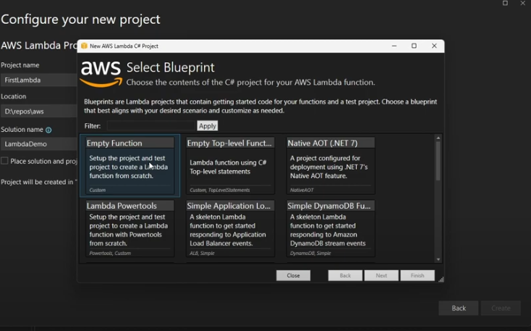  
  
  
  
**Lambda Test Tool Link - [https://github.com/aws/aws-lambda-dotnet/tree/master/Tools/LambdaTestTool  
  
https://docs.aws.amazon.com/lambda/latest/dg/with-s3-example.html](https://github.com/aws/aws-lambda-dotnet/tree/master/Tools/LambdaTestTool)**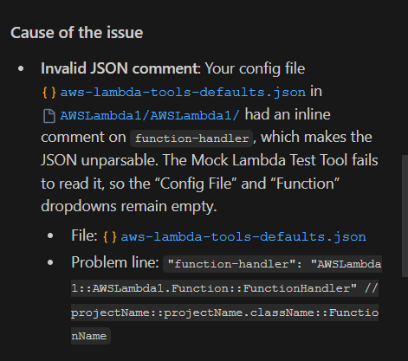  
"JSON unparsable" means that a given string or data structure, intended to be in JSON (JavaScript Object Notation) format, cannot be successfully interpreted or converted into a usable data structure by a JSON parser. This typically indicates a syntax error in the JSON data.

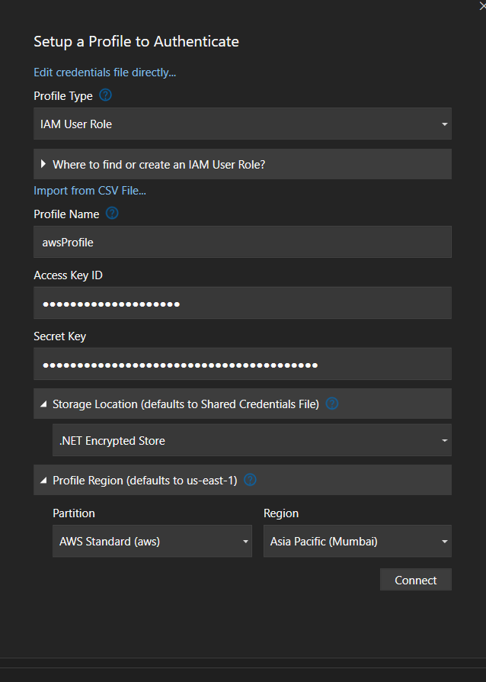

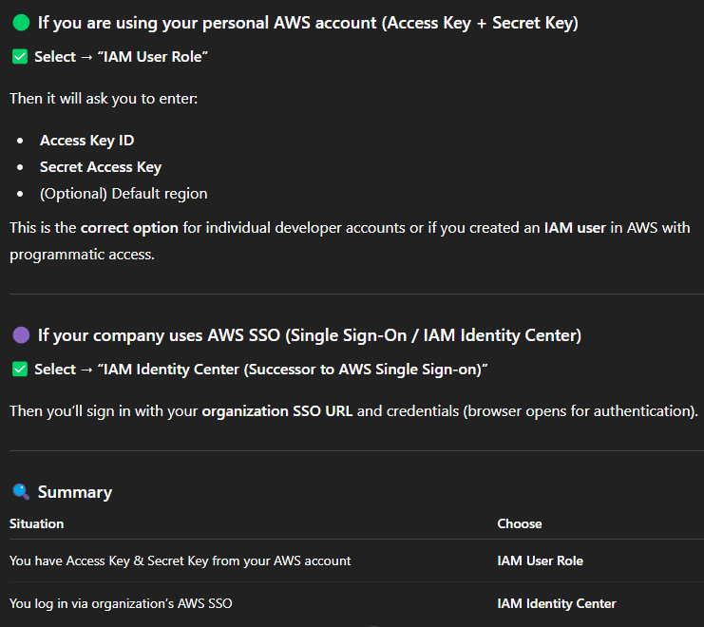

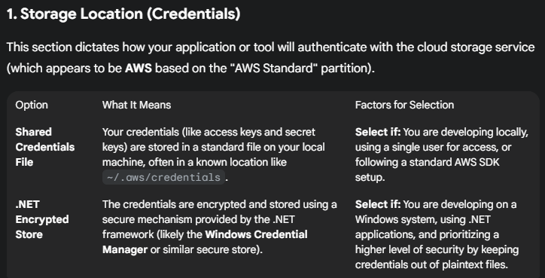

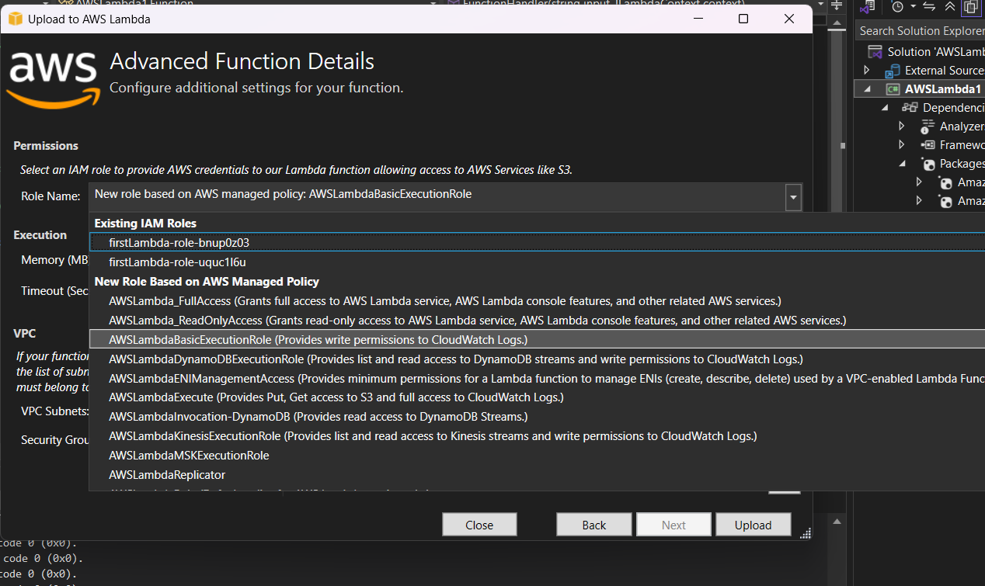  
  
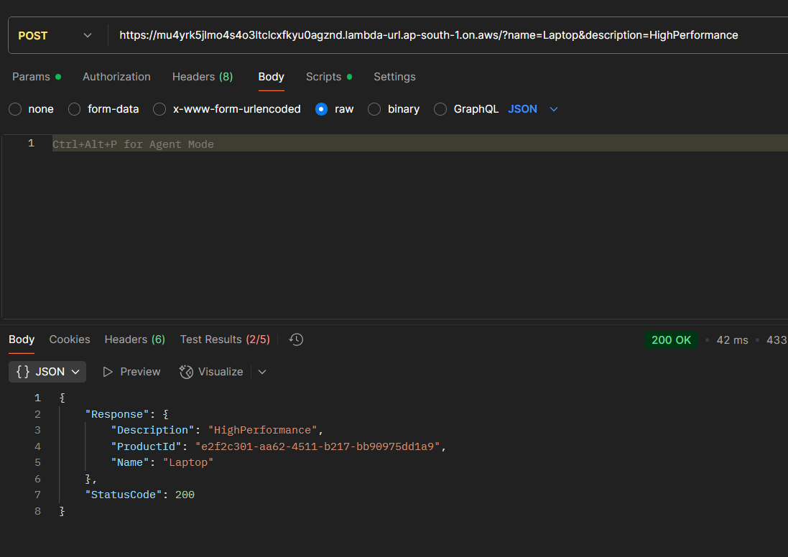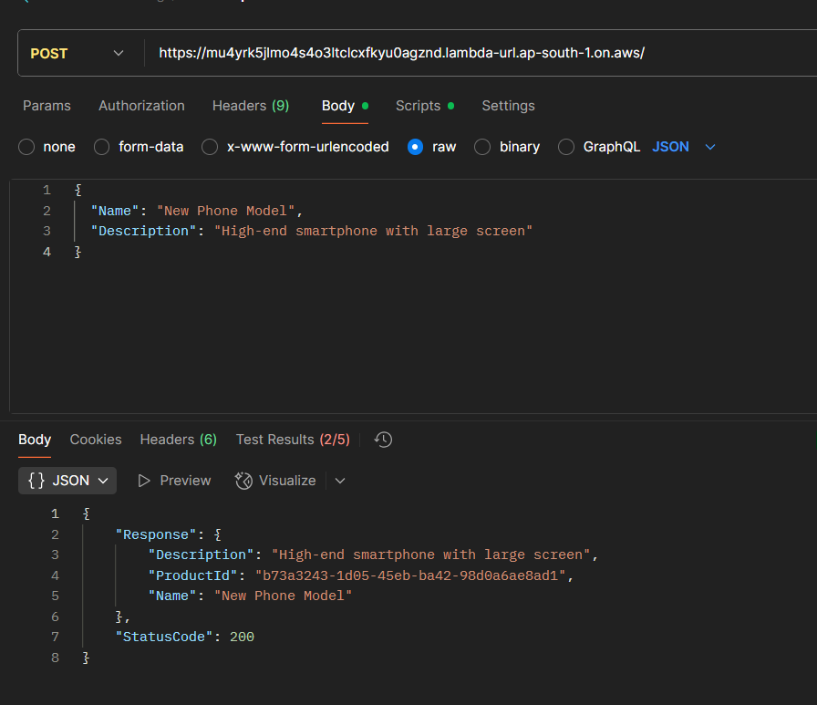  
 **to use in Lamda Mock tool**  
  
{

"httpMethod": "POST",

"body": "{\n \"Name\": \"New Phone Model\",\n \"Description\": \"High-end smartphone with large screen\"\n}",

"queryStringParameters": {

"name": "QueryName",

"description": "desc"

},

"headers": {

"Content-Type": "application/json"

},  
  
  
--------------------------------------------------------Template------------------  
  
# This AWS SAM template has been generated from your function's configuration. If

# your function has one or more triggers, note that the AWS resources associated

# with these triggers aren't fully specified in this template and include

# placeholder values. Open this template in AWS Infrastructure Composer or your

# favorite IDE and modify it to specify a serverless application with other AWS

# resources.

AWSTemplateFormatVersion: '2010-09-09'

Transform: AWS::Serverless-2016-10-31

Description: An AWS Serverless Application Model template describing your function.

Resources:

firstLambdaFunction:

Type: AWS::Serverless::Function

Properties:

CodeUri: .

Description: ''

MemorySize: 512

Timeout: 30

Handler: AWSLambda1::AWSLambda1.Function::FunctionHandler

Runtime: dotnet8

Architectures:

- x86_64

EphemeralStorage:

Size: 512

EventInvokeConfig:

MaximumEventAgeInSeconds: 21600

MaximumRetryAttempts: 2

FunctionUrlConfig:

AuthType: NONE

InvokeMode: BUFFERED

PackageType: Zip

Policies:

- Statement:

- Effect: Allow

Action:

- logs:CreateLogGroup

- logs:CreateLogStream

- logs:PutLogEvents

Resource: '*'

RecursiveLoop: Terminate

SnapStart:

ApplyOn: None

RuntimeManagementConfig:

UpdateRuntimeOn: Auto

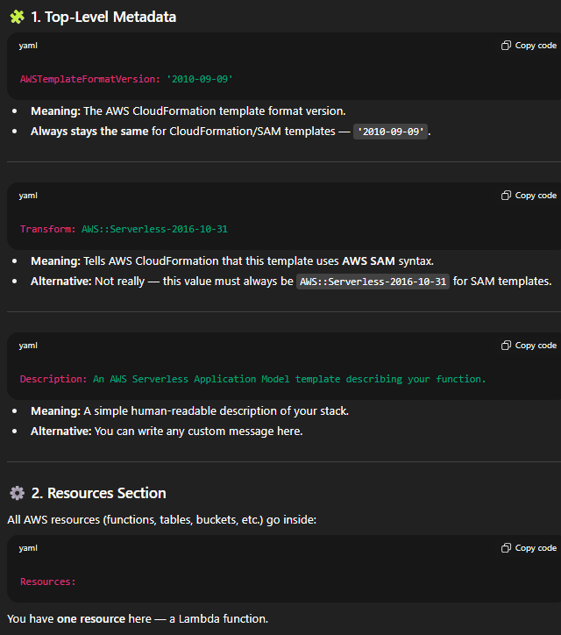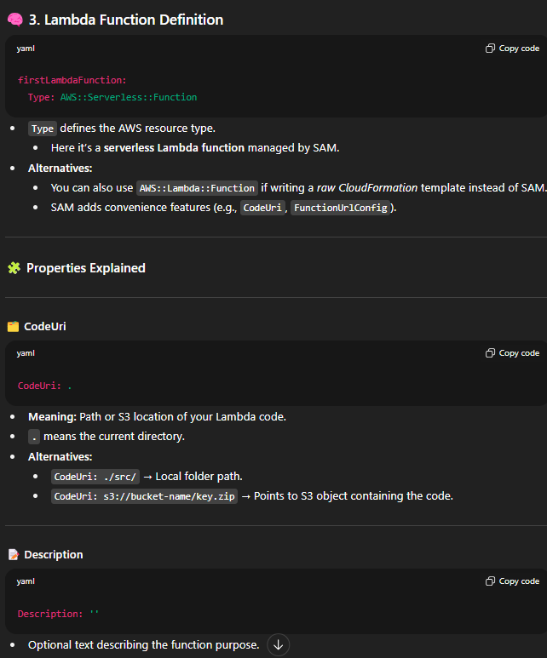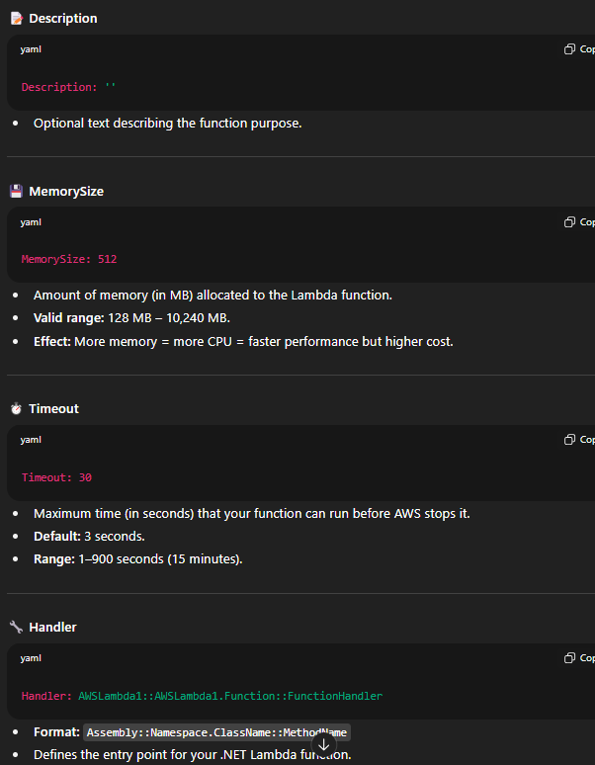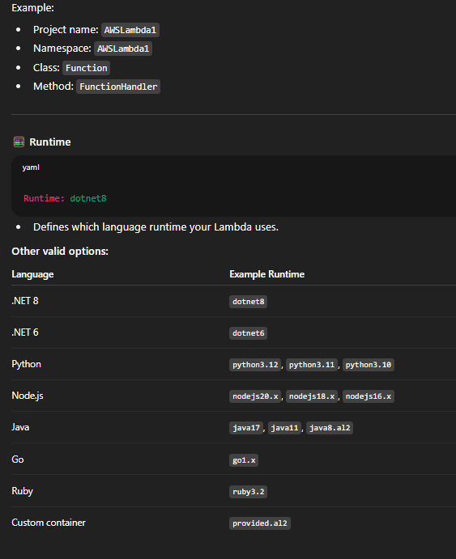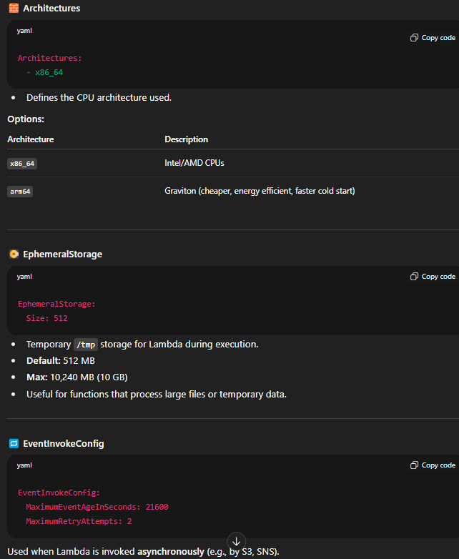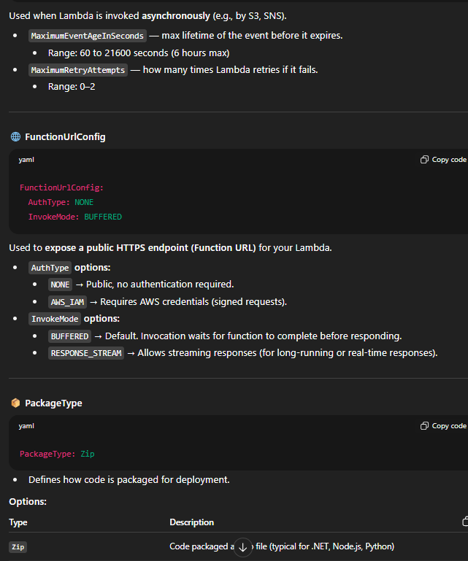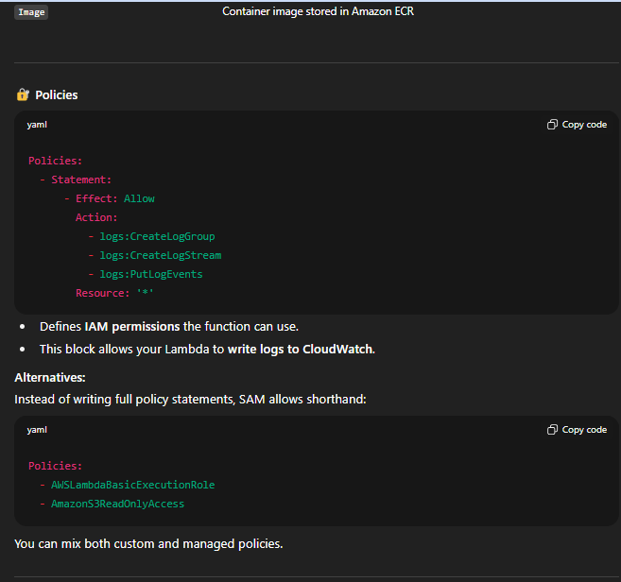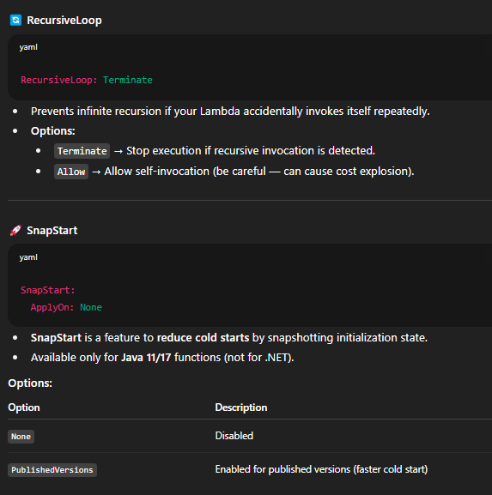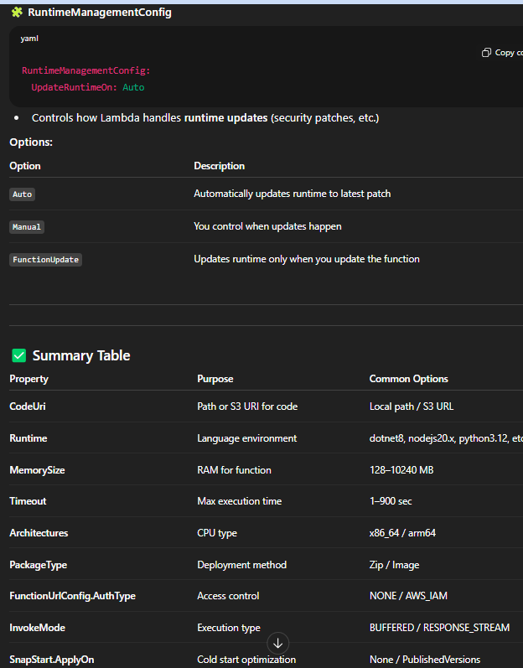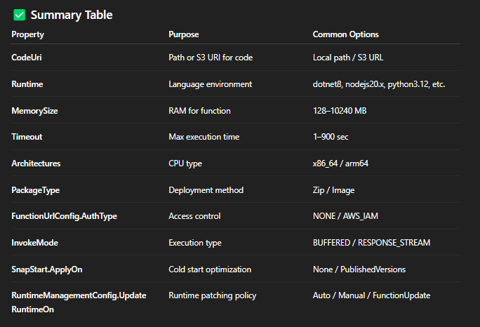

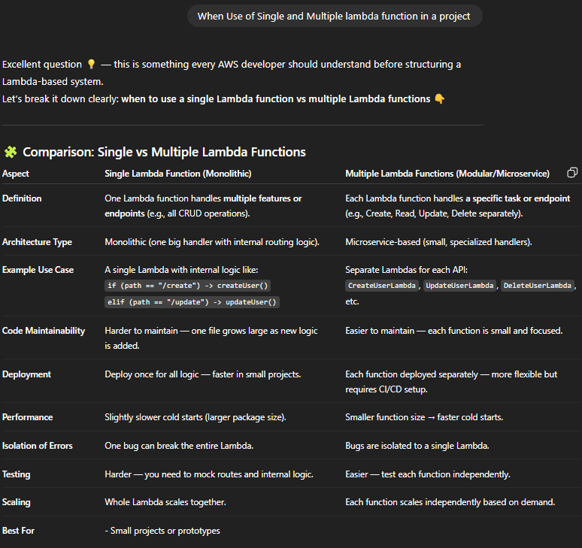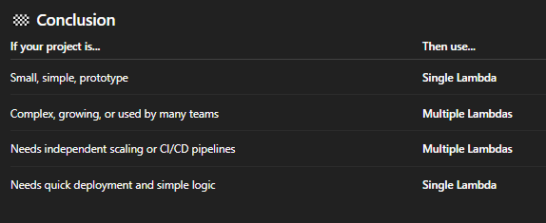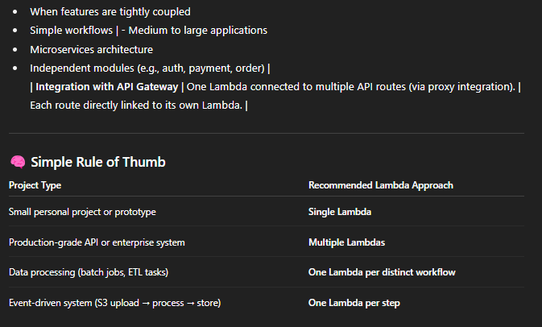

using System;

using System.Collections.Generic;

using System.Net;

using Amazon.Lambda.APIGatewayEvents;

using Amazon.Lambda.Core;

using Newtonsoft.Json;

// Assembly attribute to enable the Lambda function's JSON input to be converted into .NET class.

[assembly: LambdaSerializer(typeof(Amazon.Lambda.Serialization.SystemTextJson.DefaultLambdaJsonSerializer))]

namespace MultiRouteLambda

{

public class Function

{

public APIGatewayProxyResponse FunctionHandler(APIGatewayProxyRequest request, ILambdaContext context)

{

context.Logger.LogLine($"Received request for path: {request.Path}");

try

{

// Route logic based on the API Gateway path

switch (request.Path.ToLower())

{

case "/create":

return CreateUser(request);

case "/get":

return GetUser(request);

case "/delete":

return DeleteUser(request);

default:

return new APIGatewayProxyResponse

{

StatusCode = (int)HttpStatusCode.NotFound,

Body = "Invalid path. Supported paths are /create, /get, /delete."

};

}

}

catch (Exception ex)

{

context.Logger.LogLine($"Error: {ex.Message}");

return new APIGatewayProxyResponse

{

StatusCode = (int)HttpStatusCode.InternalServerError,

Body = $"Error occurred: {ex.Message}"

};

}

}

// -------------------- HANDLER METHODS --------------------

private APIGatewayProxyResponse CreateUser(APIGatewayProxyRequest request)

{

var body = JsonConvert.DeserializeObject<Dictionary<string, string>>(request.Body);

string name = body.ContainsKey("name") ? body["name"] : "Unknown";

return new APIGatewayProxyResponse

{

StatusCode = (int)HttpStatusCode.OK,

Body = $"User '{name}' created successfully!"

};

}

private APIGatewayProxyResponse GetUser(APIGatewayProxyRequest request)

{

string userId = request.QueryStringParameters?["id"];

return new APIGatewayProxyResponse

{

StatusCode = (int)HttpStatusCode.OK,

Body = $"Fetched user with ID: {userId}"

};

}

private APIGatewayProxyResponse DeleteUser(APIGatewayProxyRequest request)

{

string userId = request.QueryStringParameters?["id"];

return new APIGatewayProxyResponse

{

StatusCode = (int)HttpStatusCode.OK,

Body = $"User with ID {userId} deleted successfully!"

};

}

}

}

**Cold Start and hot start**  
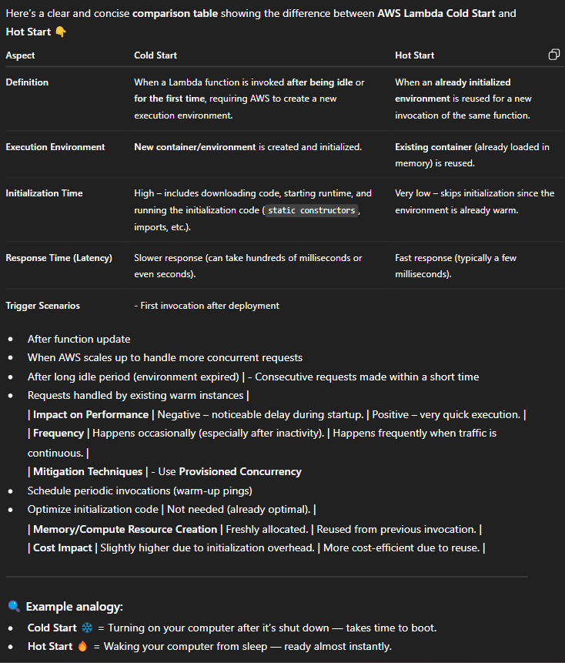  
  
**To understand working of cold and hot start**  
  
using System;

using System.Net;

using System.Collections.Generic;

using Amazon.Lambda.Core;

using Amazon.Lambda.APIGatewayEvents;

[assembly: LambdaSerializer(typeof(Amazon.Lambda.Serialization.SystemTextJson.DefaultLambdaJsonSerializer))]

public class Function

{

// ✅ This static variable stays in memory as long as the Lambda container is warm

private static DateTime? coldStartTime = null;

public APIGatewayProxyResponse FunctionHandler(APIGatewayProxyRequest request, ILambdaContext context)

{

string startType;

if (coldStartTime == null)

{

// First time — cold start

coldStartTime = DateTime.UtcNow;

startType = "Cold Start";

}

else

{

// Same container reused — hot start

startType = "Hot Start";

}

var response = new Dictionary<string, string>

{

{ "start_type", startType },

{ "cold_start_time", coldStartTime?.ToString("O") },

{ "current_time", DateTime.UtcNow.ToString("O") }

};

return new APIGatewayProxyResponse

{

StatusCode = (int)HttpStatusCode.OK,

Body = System.Text.Json.JsonSerializer.Serialize(response),

Headers = new Dictionary<string, string> { { "Content-Type", "application/json" } }

};

}

}  
  
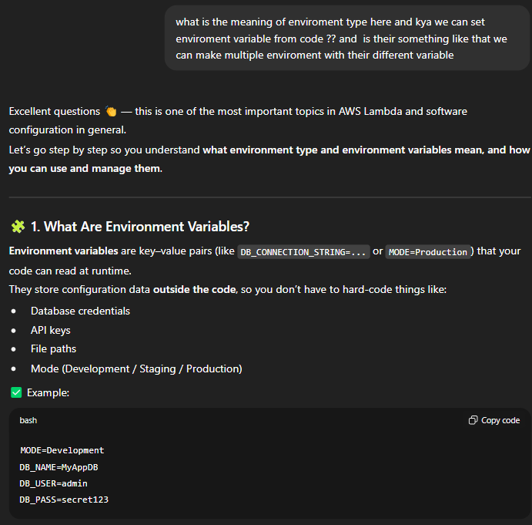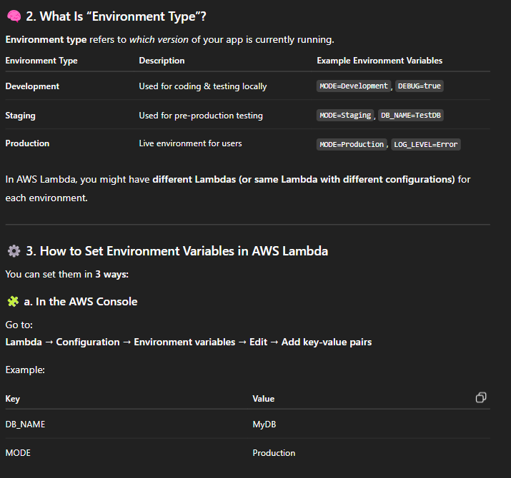

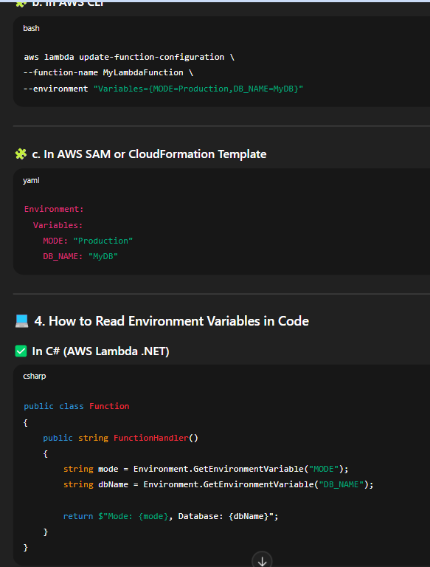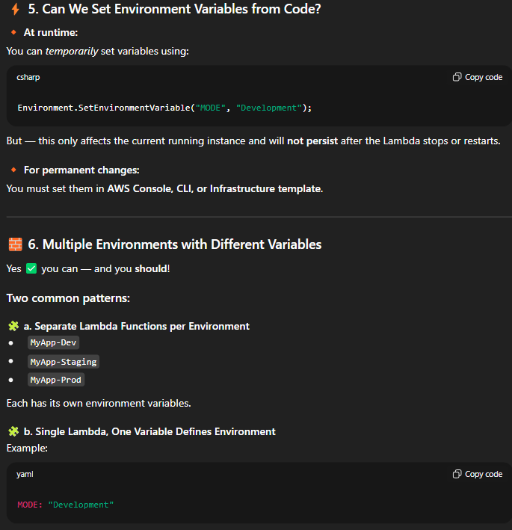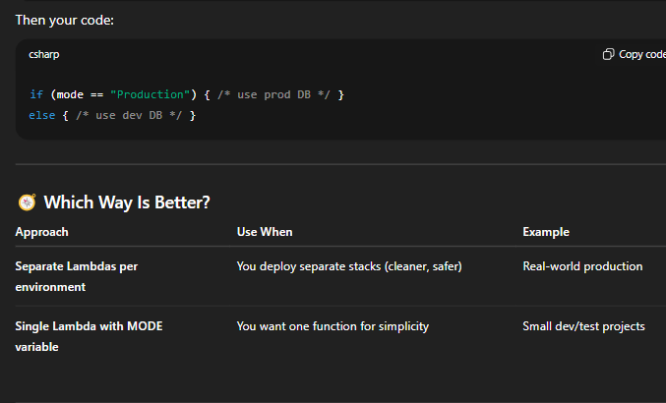

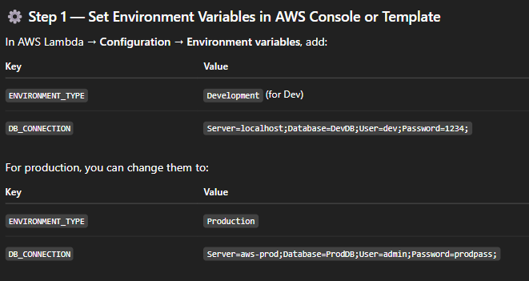

using System;

namespace MyLambdaApp

{

public class Function

{

public string FunctionHandler()

{

// Get environment variables

string envType = Environment.GetEnvironmentVariable("ENVIRONMENT_TYPE");

string dbConnection = Environment.GetEnvironmentVariable("DB_CONNECTION");

string message = string.Empty;

if (envType == "Production")

{

message = $"Running in {envType} mode. Connecting to Production DB.";

}

else if (envType == "Development")

{

message = $"Running in {envType} mode. Connecting to Development DB.";

}

else

{

message = "Environment type not set. Running in default mode.";

}

// Simulate DB connection using the variable

return $"{message}\nDB Connection String: {dbConnection}";

}

}

}

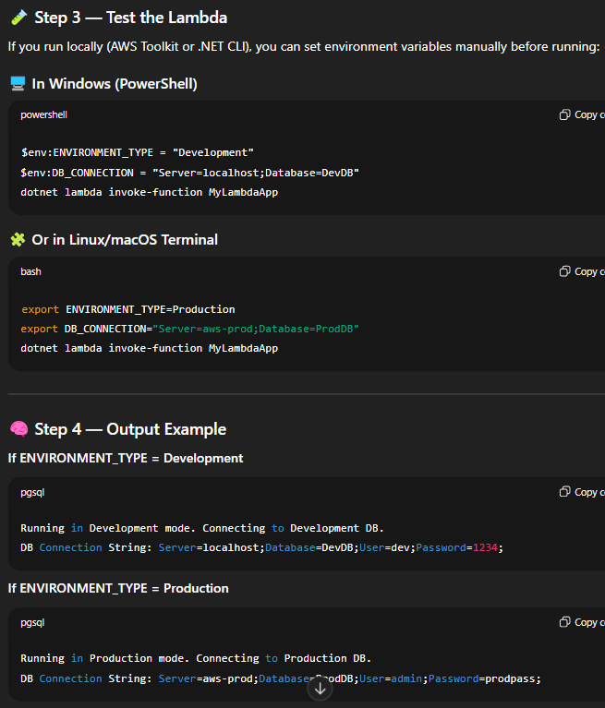

**Some use of Enviroment variables::**  
if want to enable and disable any feature, keep api endpoint(url) and try not to keep your secret in it

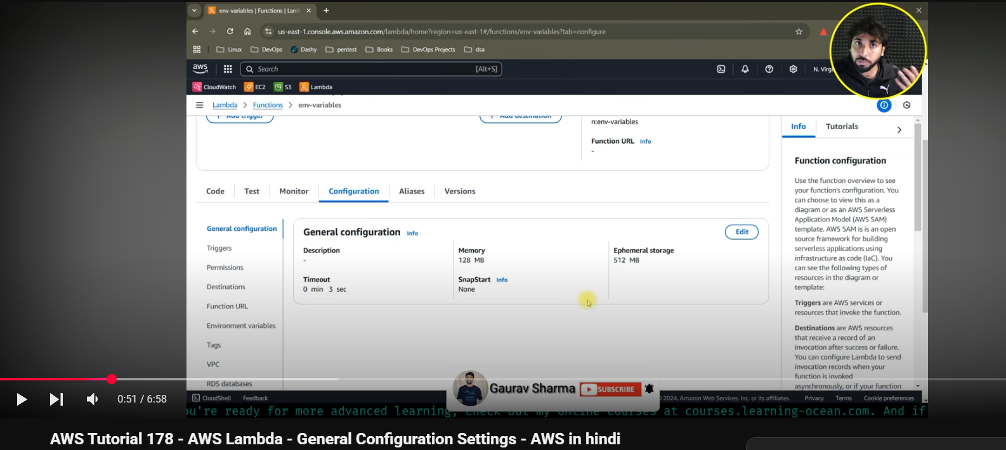  
  
Here memory means if 10 set and in one run if 5 used tabhi 10 a paisa dena hoga so memory price ko dhayan m rakhte hue kerna.(128 MB to 10240MB)

Here CPU core depend kerta on memory means jitna increse memory utna CPU core increase means you can use multithreading ….your code will be more efficient.

Empherel Storage is used for storing any downloaded file/folder ftom internet in your Lambda function so eska size depend on aap kitne size ka file downloading.(512 MB to 10240 MB)  
  
Timeout if 5sec and our Lambda taking more then we will come out with error.(Max is 15min only)

SnapStart - Reduce startup time by having Lambda Casche a snapshot of your function after the function have initialized.

**Context Object**  
  
The **AWS Lambda Context object** is a core component passed to your function's handler, providing essential **runtime information** about the function, its execution environment, and the current invocation.

It contains properties (attributes) and methods for tasks like monitoring, debugging, and managing execution time.

## Key Information in the Context Object

The specific implementation and naming conventions may vary slightly by runtime (e.g., Python uses function_name, Node.js uses functionName), but the information provided is fundamentally the same.

| **Property/Method** | **Description** |
| --- | --- |
| **function_name** | The name of the Lambda function. |
| **function_version** | The version of the function being executed (e.g., $LATEST or a published version number). |
| **invoked_function_arn** | The **Amazon Resource Name (ARN)** used to invoke the function, which can indicate if an alias or a specific version was used. |
| **memory_limit_in_mb** | The amount of memory allocated for the function (in MB). |
| **aws_request_id** | A **unique identifier** for the current invocation request, critical for logging and debugging. |
| **log_group_name** | The CloudWatch Log Group name for the function (e.g., /aws/lambda/my-function). |
| **log_stream_name** | The CloudWatch Log Stream name for the current function instance, which helps locate logs for a specific execution environment. |
| **get_remaining_time_in_millis()** | A method that returns the **remaining execution time** (in milliseconds) before the function times out. This is vital for time-sensitive operations. |
| **identity** | (Mobile apps only) Information about the **Amazon Cognito identity** that authorized the request. |
| **client_context** | (Mobile apps only) Client context provided by the invoking application, useful for mobile backends. |

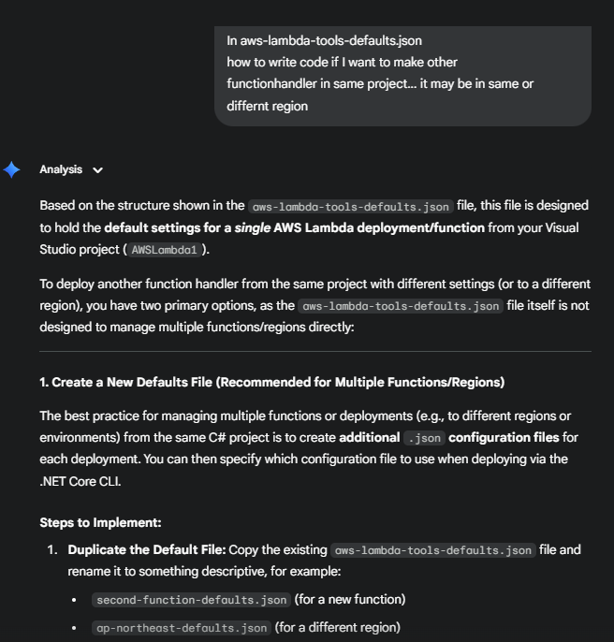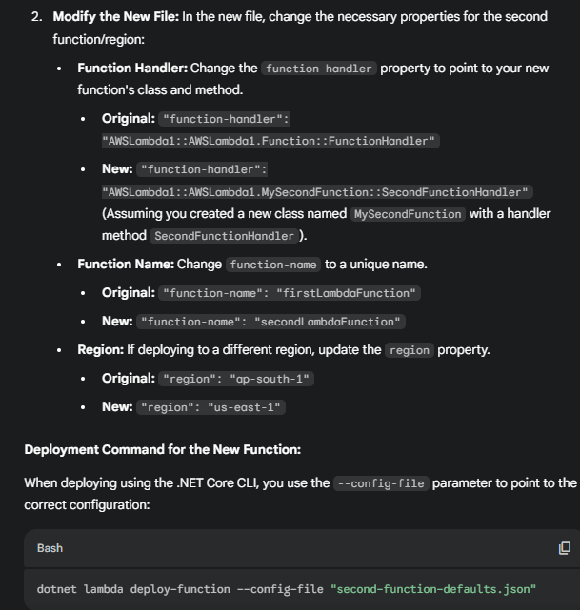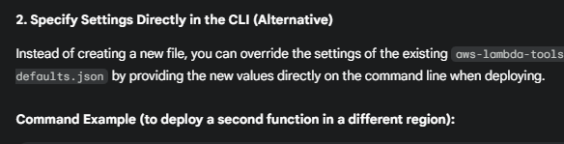  
dotnet lambda deploy-function --function-handler "AWSLambda1::AWSLambda1.MySecondFunction::SecondFunctionHandler" --function-name "secondLambdaFunction" --region "us-east-1"

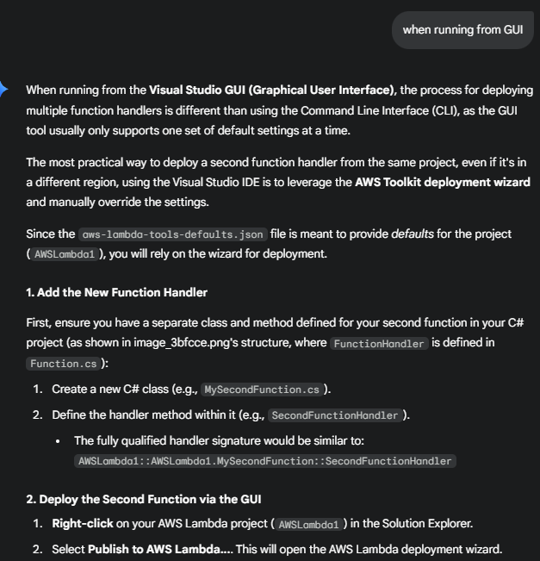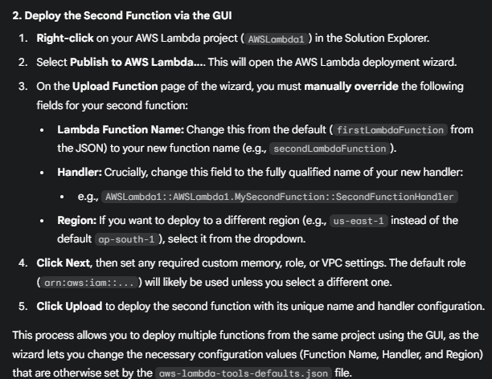

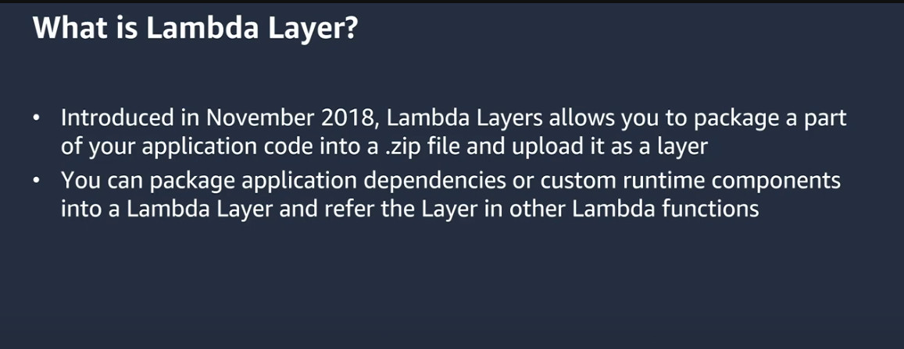

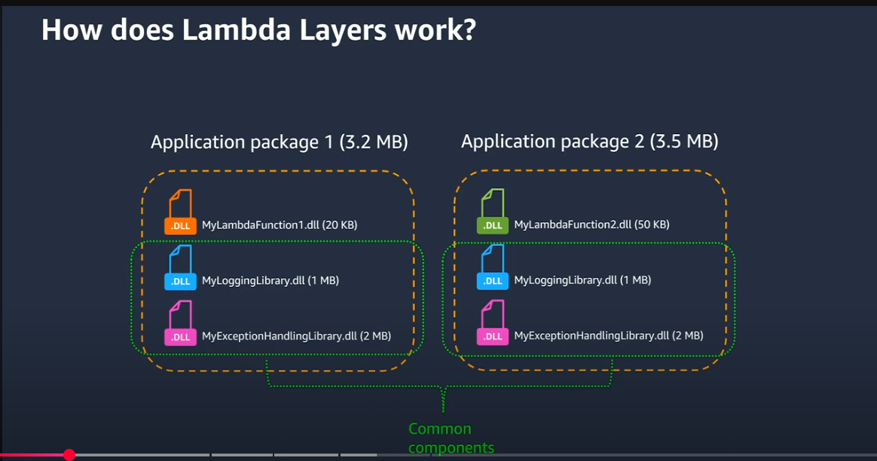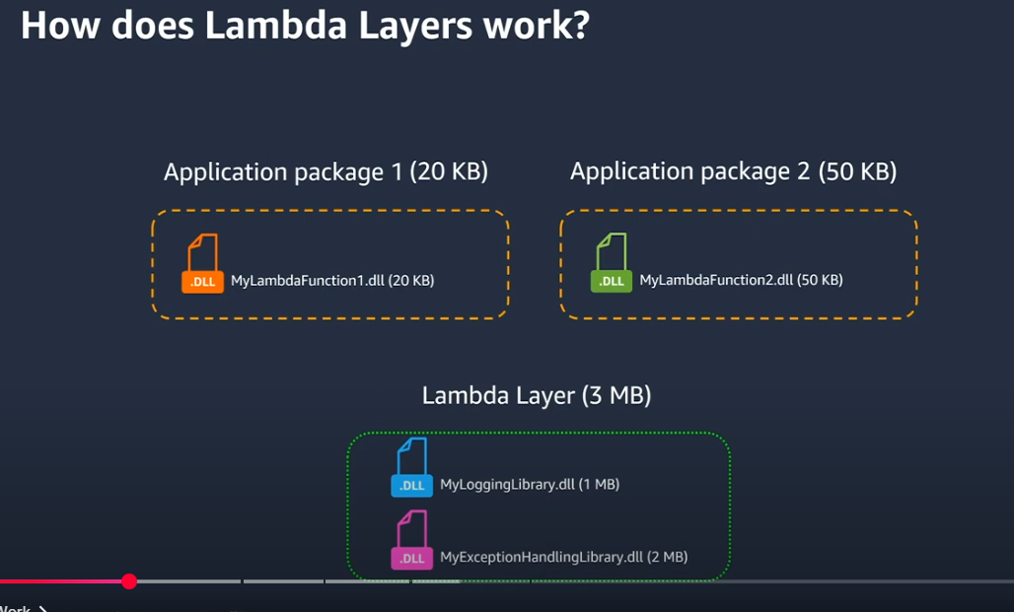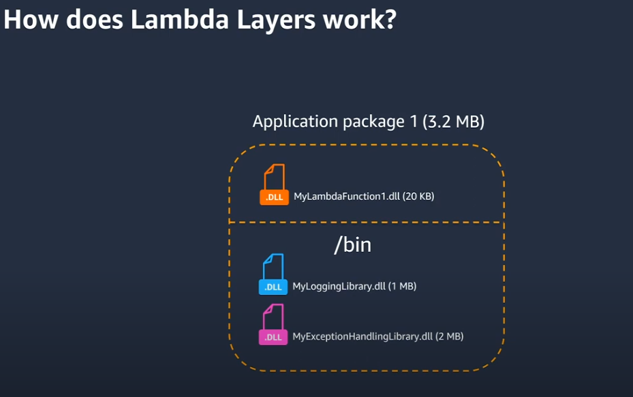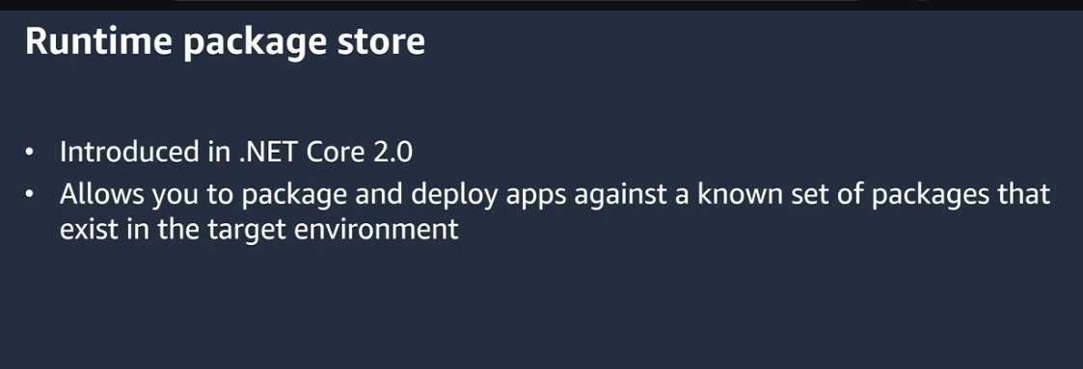

In a **.NET C# Lambda project**, you **do not directly write code** to interact with the layer itself. Instead, the layer is used to store and provide dependencies (assemblies/DLLs) to your function at runtime, and your C# code uses these dependencies just like any other package reference.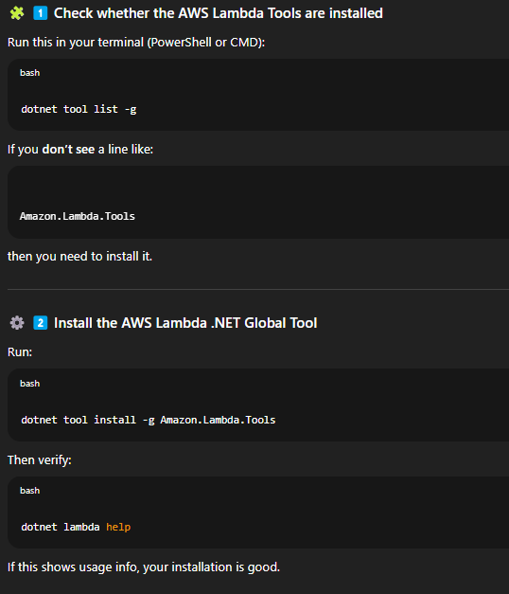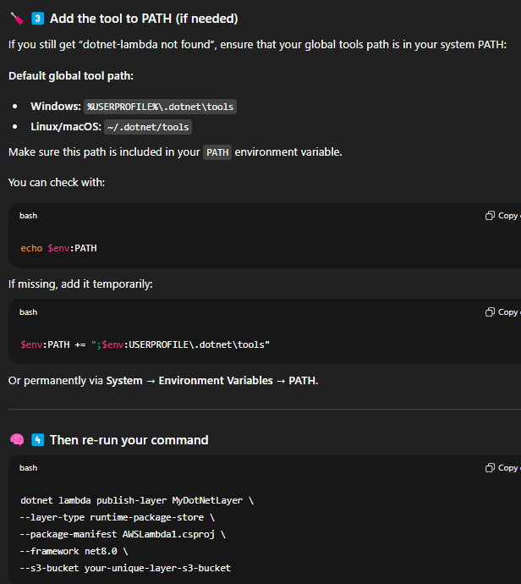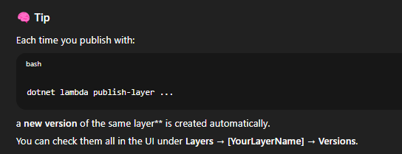



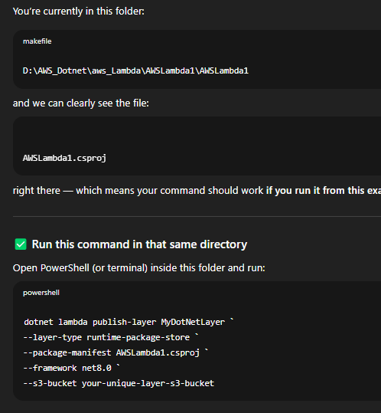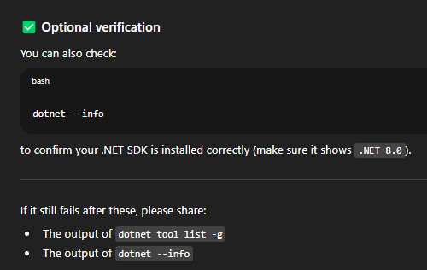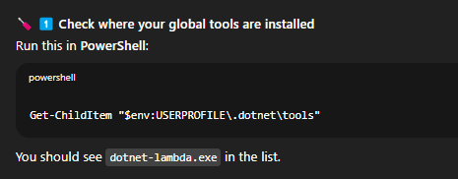  
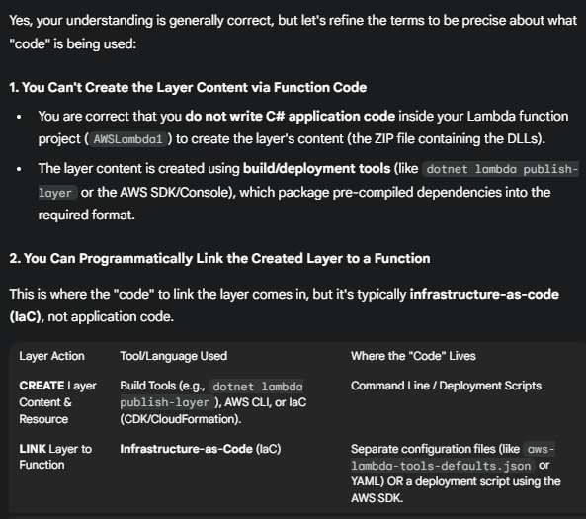  
  
dotnet lambda publish-layer MyDotNetLayer \

--layer-type runtime-package-store \

--package-manifest MySharedLayerManifest.csproj \

--framework net8.0 \

--s3-bucket your-unique-layer-s3-bucket

| **Part of Command** | **Value in Example** | **Explanation** |
| --- | --- | --- |
| **dotnet lambda publish-layer** | MyDotNetLayer | This is the core command from the Amazon.Lambda.Tools global tool. It tells the tool to take content, package it into a Lambda Layer format, upload it to S3, and register it with the AWS Lambda service under the name **MyDotNetLayer**. |
| **--layer-type** | runtime-package-store | This is crucial for **.NET**. It instructs the tool to build the layer in a specific format that the .NET runtime (like dotnet8) can natively recognize. It essentially creates a pre-compiled set of DLLs (assemblies) and metadata that the Lambda environment loads from the /opt directory. |
| **--package-manifest** | MySharedLayerManifest.csproj | This specifies the **input file** that defines the content of your layer. It must be a standard .NET project file (.csproj) that contains <PackageReference> items listing all the NuGet packages (dependencies) you want to include in the layer. |
| **--framework** | net8.0 | This defines the target .NET framework for the layer's assemblies. It must match the framework of your Lambda function (which in your initial context was also net8.0). |
| **--s3-bucket** | your-unique-layer-s3-bucket | AWS Lambda requires the layer package (a .zip file created by the tool) to be staged in an **S3 bucket** before the layer resource can be created. This parameter specifies the name of the S3 bucket where the tool will upload the package. |
|  |  |  |

**Attach Your Layer to a Lambda Function**

You can also attach the layer using AWS CLI:  
aws lambda update-function-configuration `

--function-name MyLambdaFunction `

--layers arn:aws:lambda:ap-south-1:371447792479:layer:MyDotNetLayer:1

**Aap ek Lambda function ke saath maximum 5 layers attach kar sakte ho.**

**Ye 5 layers plus aapka function code milke runtime environment banate hain.**

**Agar aapko aur libraries ya dependencies chahiye, to aap:**

**unko combine karke ek hi layer me rakh sakte ho (multiple dependencies in one layer), ya**

**apne function package me directly include kar sakte ho.**

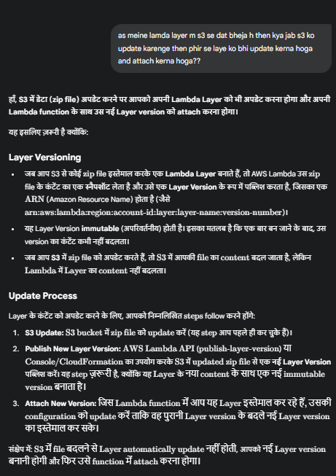

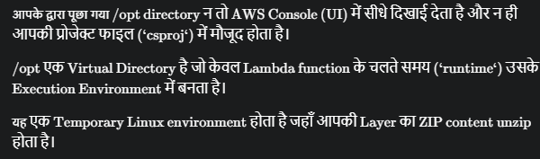

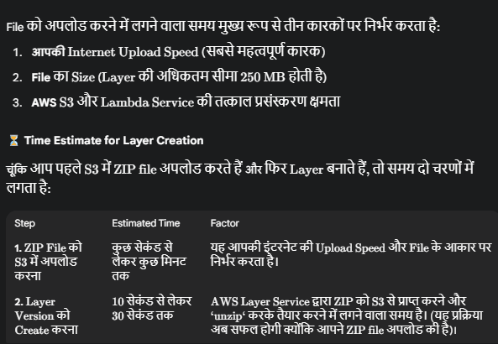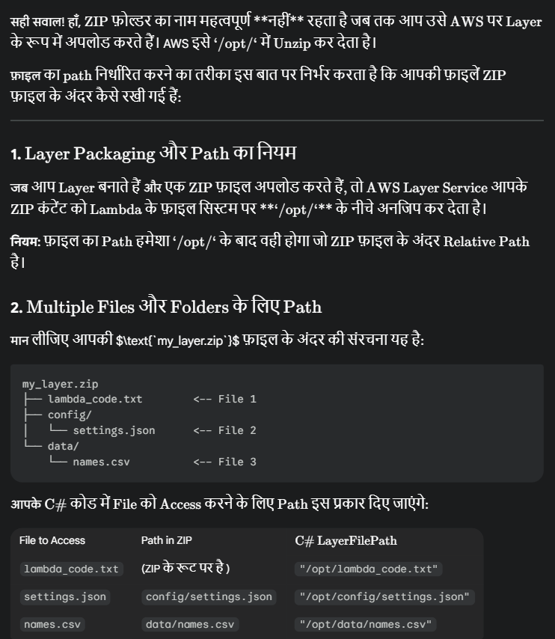



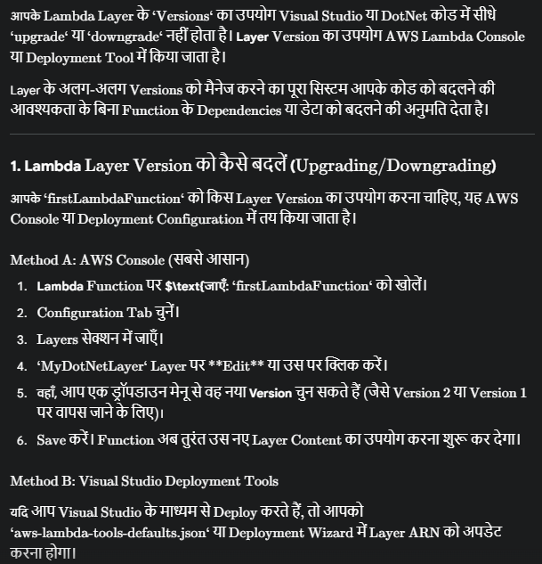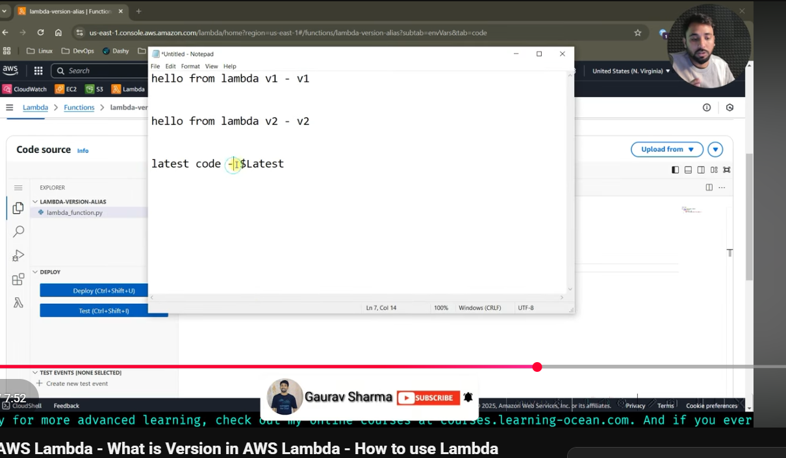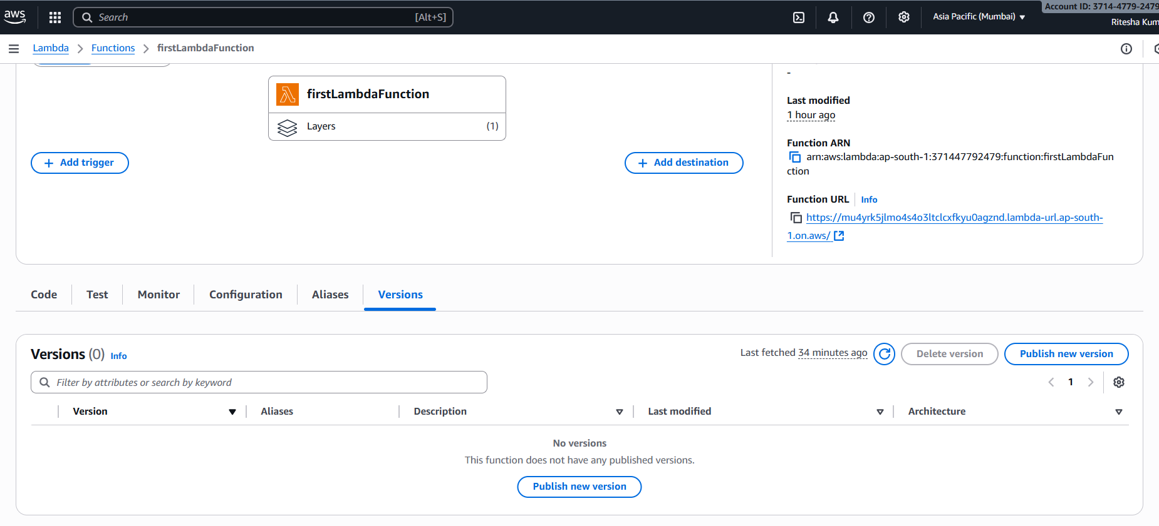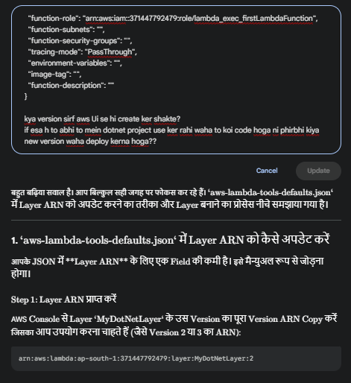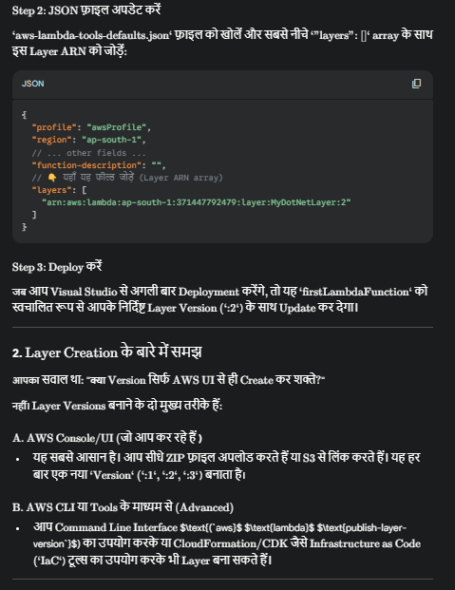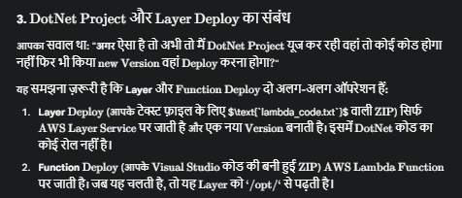

Live poject m jo change wo latest version m change hota.

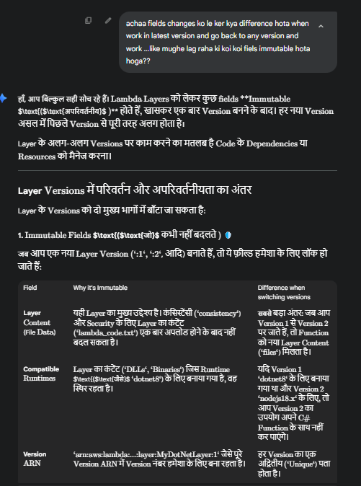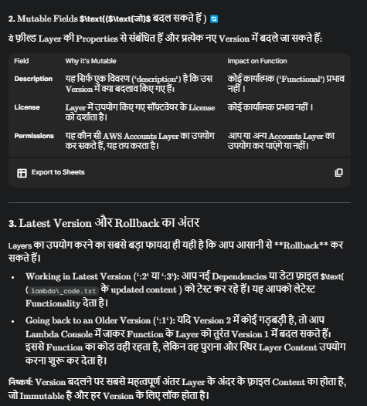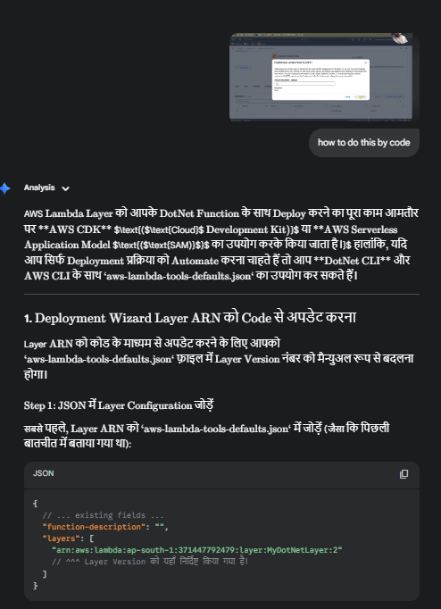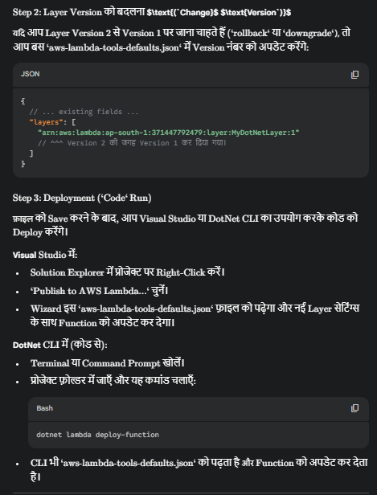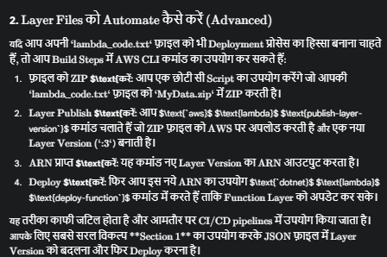

Alias point to version(VVI topic as yaha se hum apne function ke versions ko handle ker shakte)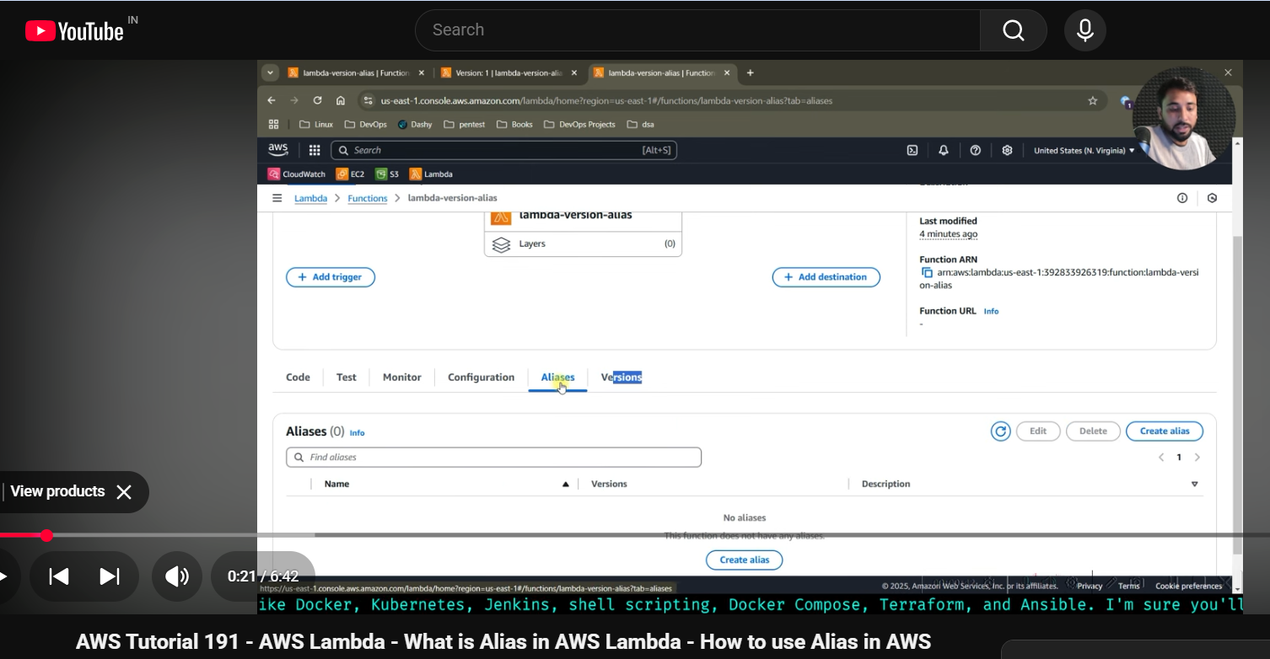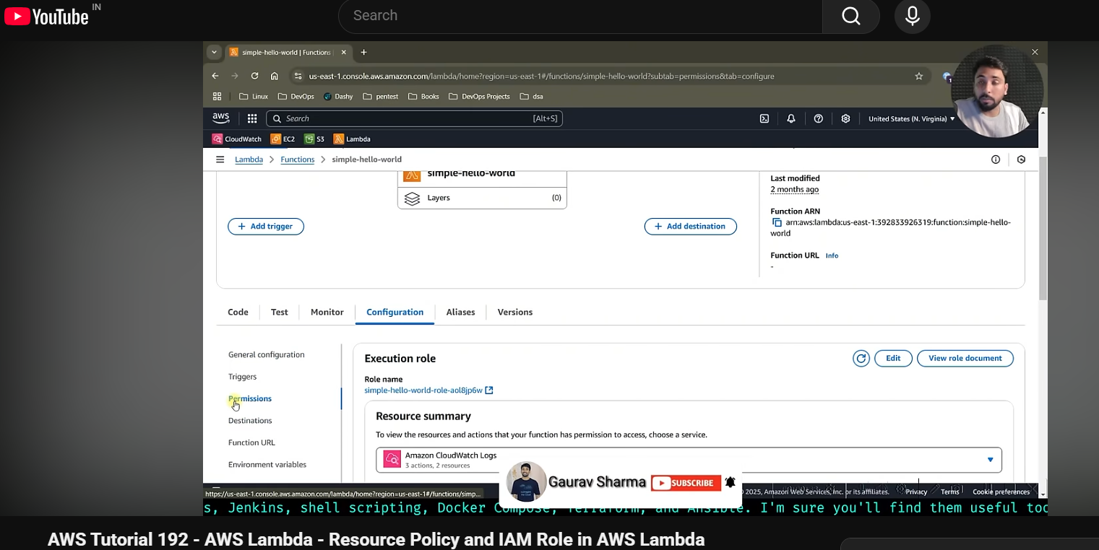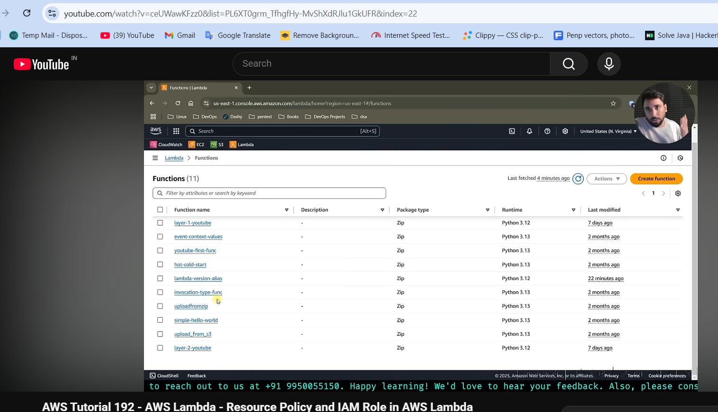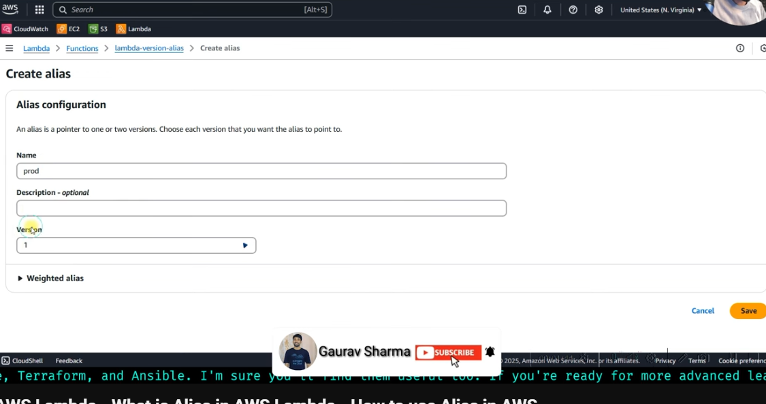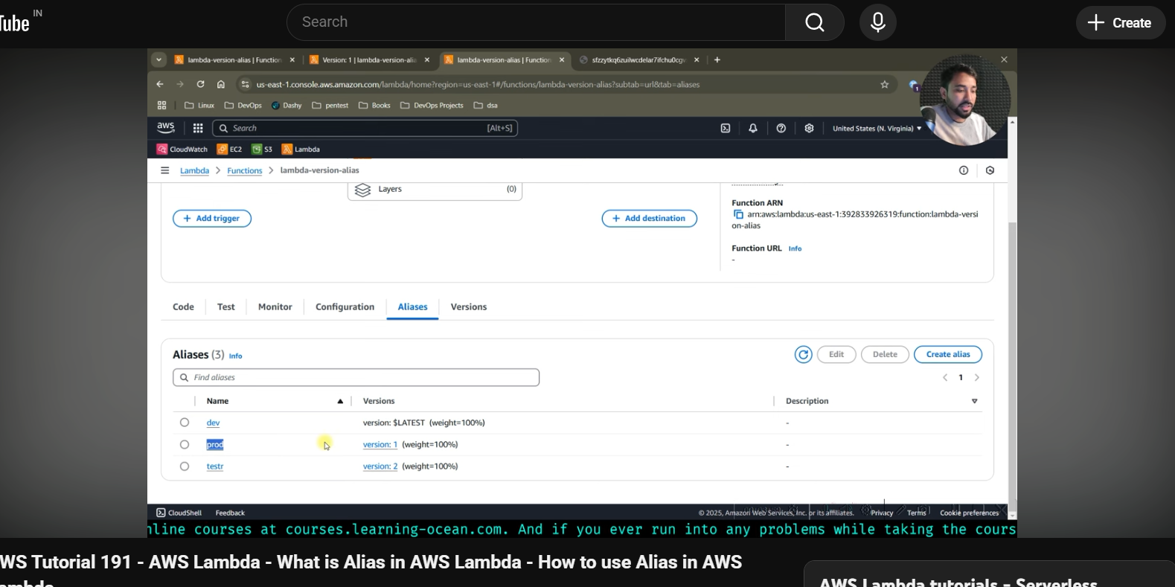

Jab hum vpc include ni kerte then bydefault hamara lambda us VPC m hota jo aws khud manage ker raha hota hum ni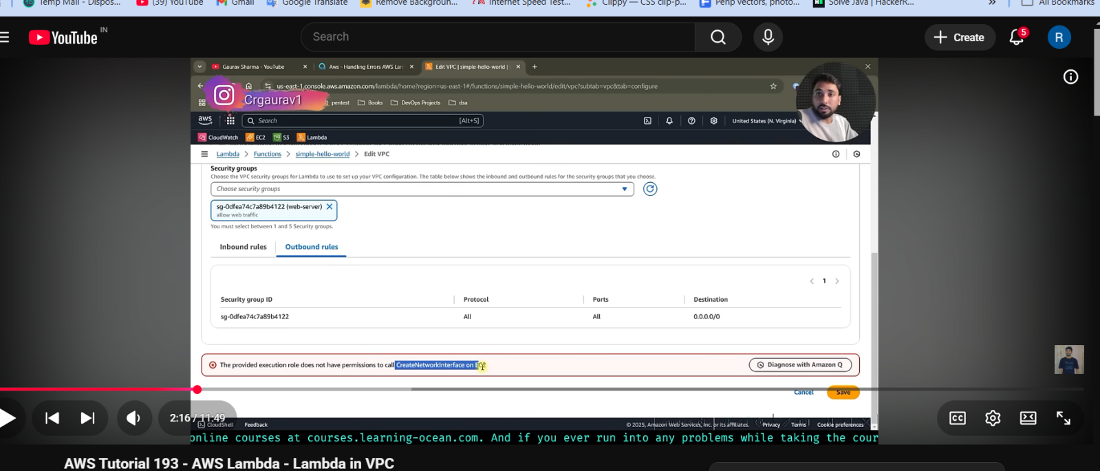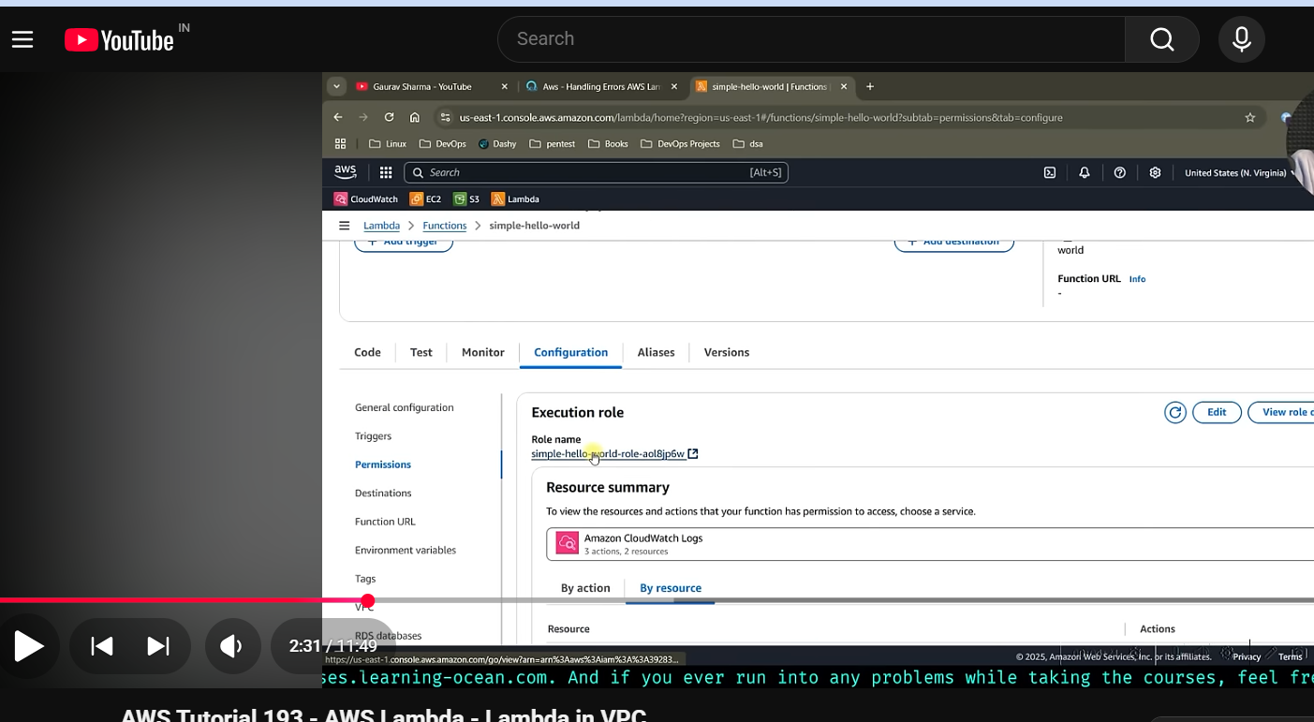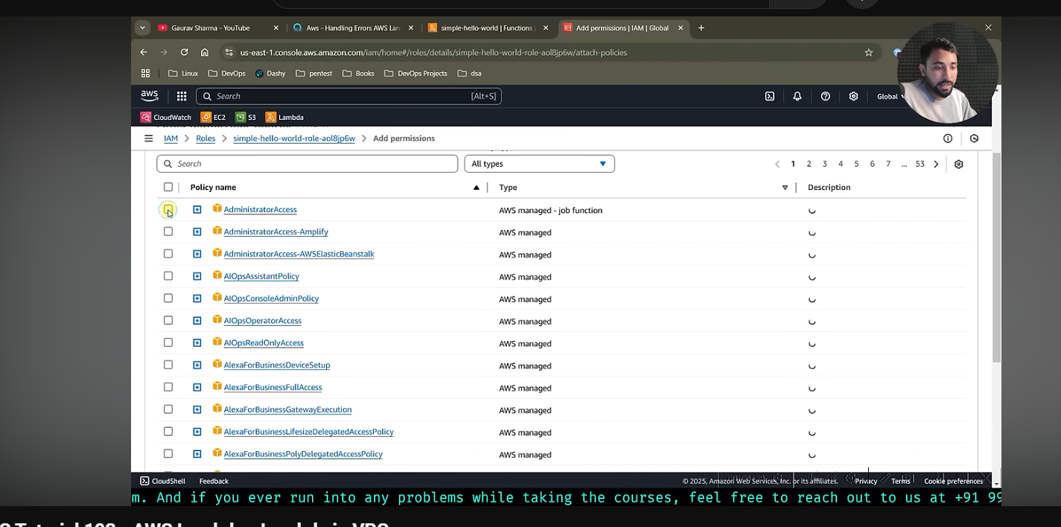  
now edit your VPC ..first time time lagega  
  
Also remember when apna vpc create and wo connect then (public ya private )subnet …dono hi case m internet connectivity ni lega when connect to lamda  
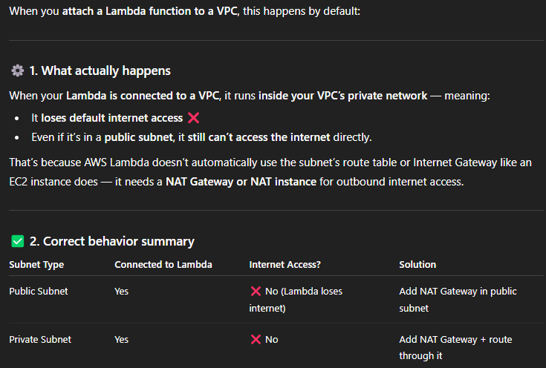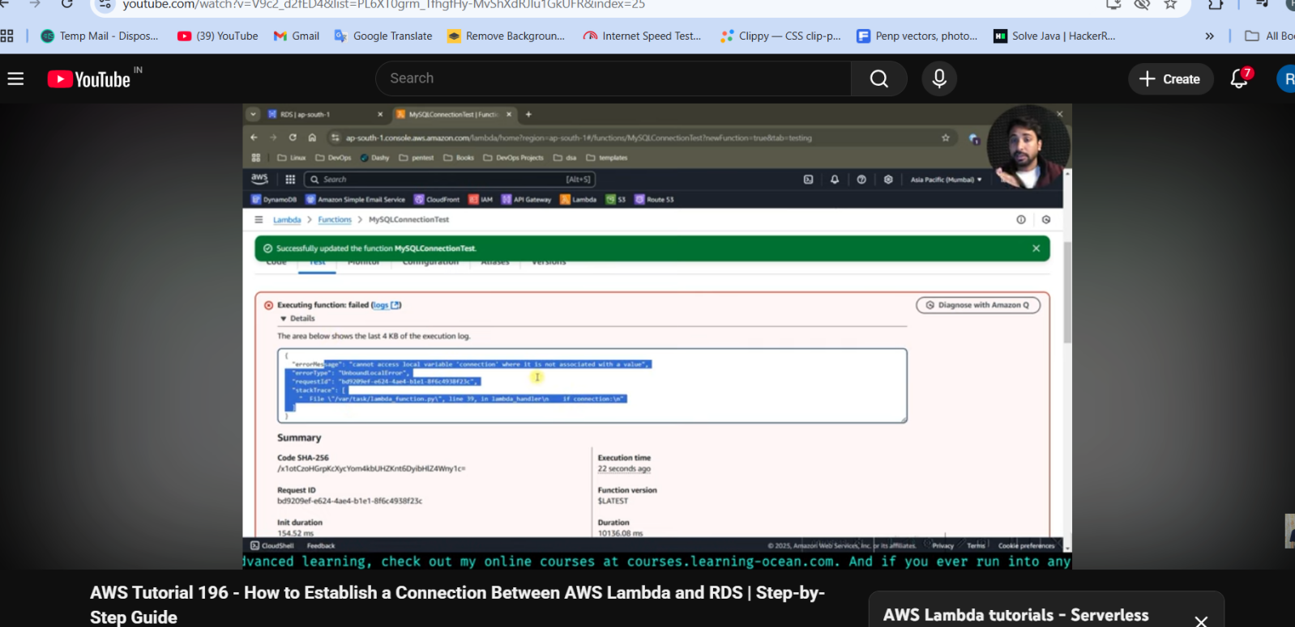  
  
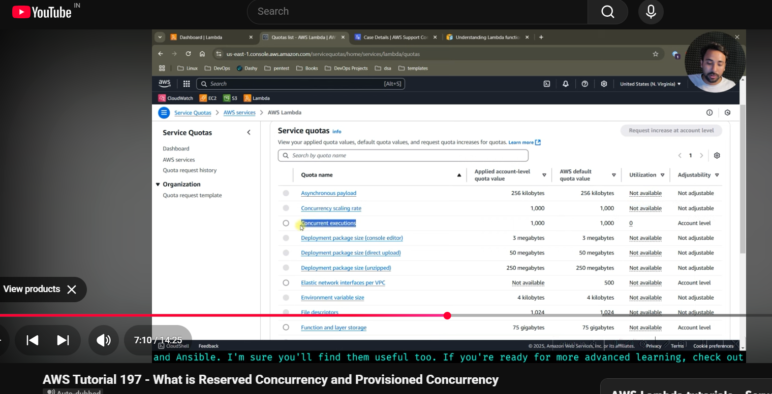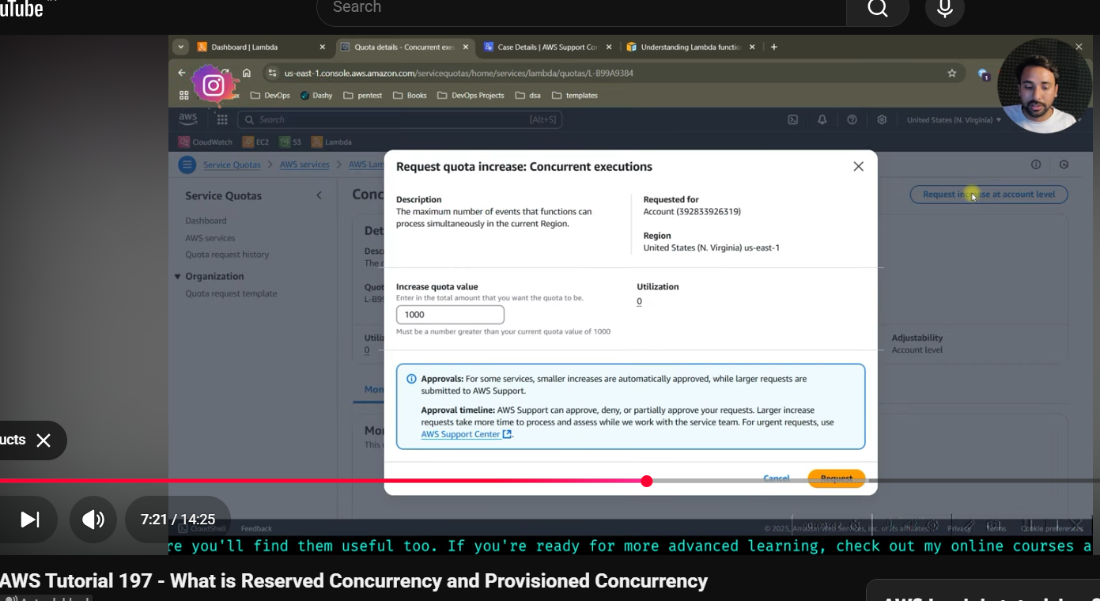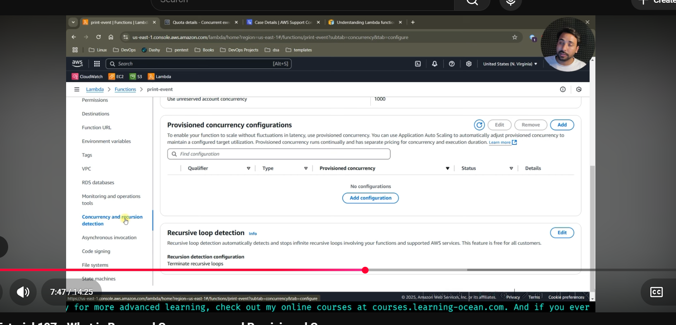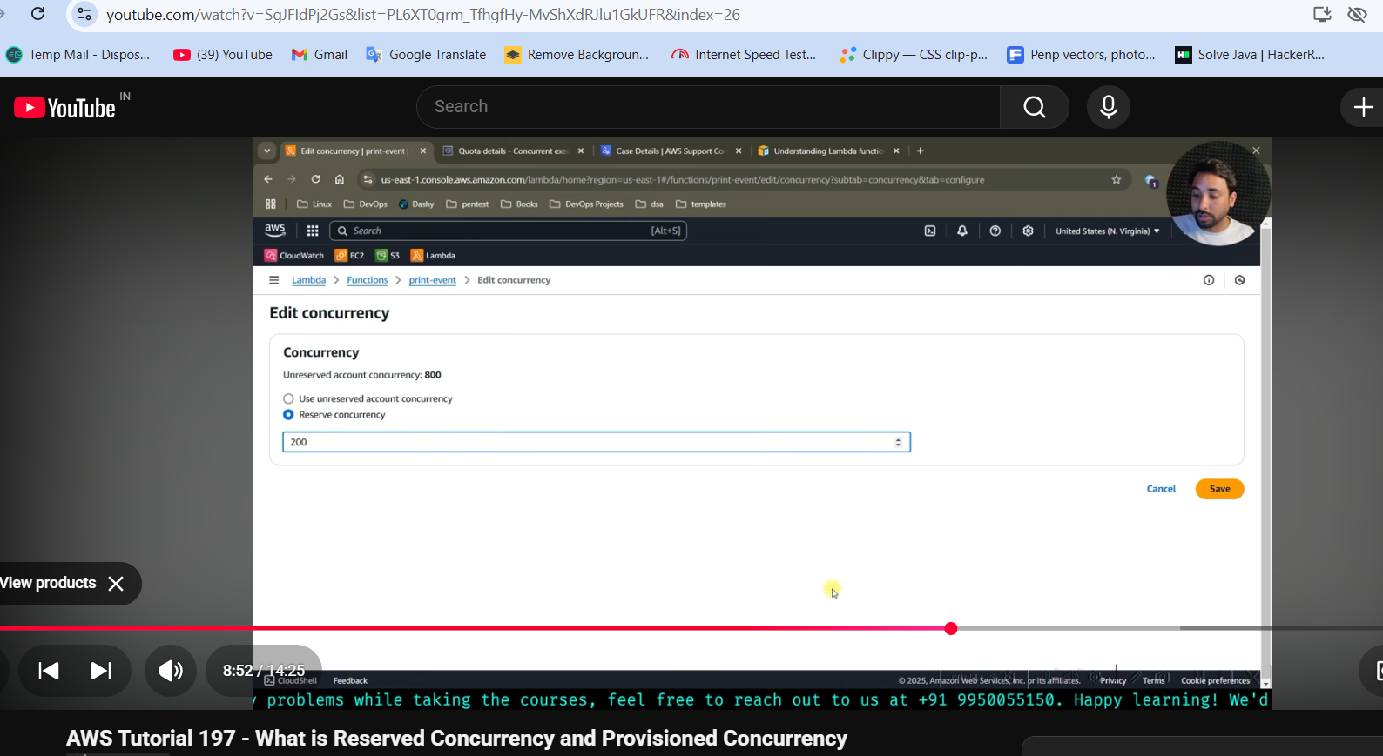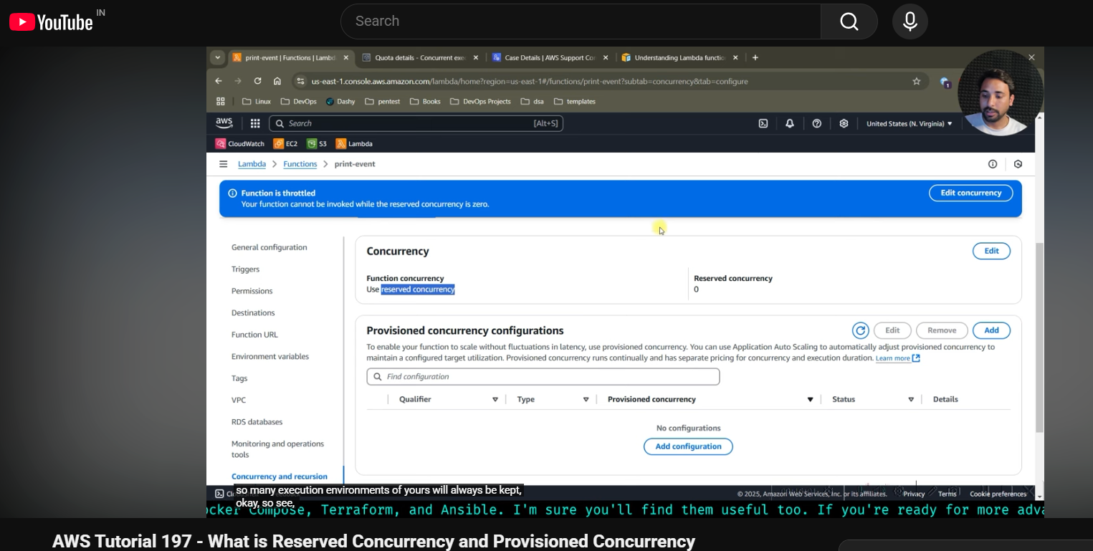

**Difference between Reserved and Provisioned Concurrency**

| **Feature** | **Reserved Concurrency** | **Provisioned Concurrency** |
| --- | --- | --- |
| **Purpose** | To **limit or guarantee** the maximum number of concurrent executions for a function. | To **pre-warm instances** of a Lambda function for **zero cold starts**. |
| **Main Use Case** | Prevent other functions from consuming all concurrency or ensure a minimum concurrency for critical functions. | Ensure consistent low-latency performance (no cold start) for high-traffic or latency-sensitive functions. |
| **Cold Start** | ❌ Cold starts can still happen. | ✅ Eliminates cold starts — functions are pre-initialized. |
| **How it works** | Reserves a portion of your account’s total concurrency limit for one function. | Keeps a specific number of function instances **initialized and ready** to respond immediately. |
| **Billing** | You’re billed only for **invocations and execution time** (normal Lambda pricing). | You’re billed for the **provisioned concurrency time** (kept warm) **+** normal invocation cost. |
| **Configuration Scope** | Controls **how many concurrent instances** can run for a function. | Controls **how many pre-initialized instances** are always ready. |
| **Helps avoid throttling?** | ✅ Yes — guarantees concurrency for critical functions. | ⚠️ Indirectly — ensures warm starts, but does not control throttling directly. |
| **Performance Impact** | Normal performance with possible cold starts. | Much faster — consistent low latency responses. |
| **Ideal For** | Workload management and concurrency control across multiple functions. | Latency-sensitive or high-traffic APIs (e.g., user-facing applications). |
| **Example** | You reserve 20 out of 100 total concurrency for a critical function. | You provision 10 instances to stay warm 24/7 for quick response. |

👉 In short:

Reserved Concurrency = Controls how many can run (limits or guarantees).

# Provisioned Concurrency = Controls how fast they respond (pre-warms instances) - like in project pata h kuch ;lambda function baar baar call hota …use hota in each execution then esme dal do jises uska hot reload jaisa work …na ki suru se sara load hoga esse user jo aa rahe and getting late reply can be handled by Provisioned Concurrency When your lambda function is called asynchrounously then only can use destination in Lambda. Destination in Lambda is used when we want output of its execution become input for other.Max 2 destination can add ,one for success and other for failure

**Throttling**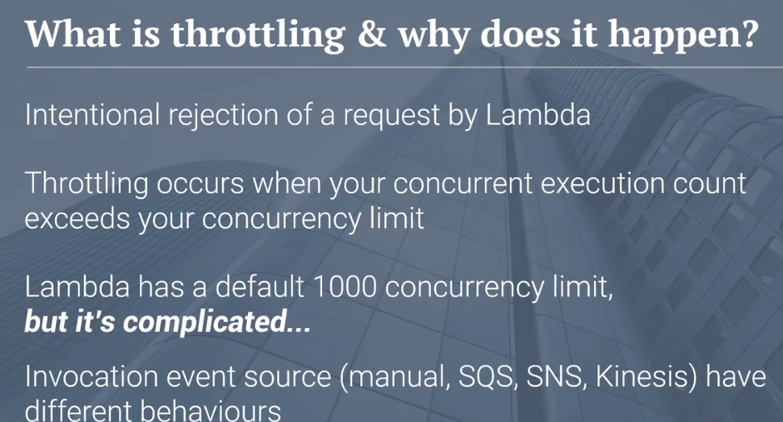

But sometimes due to this case arise like koi lambda function is accepting no one request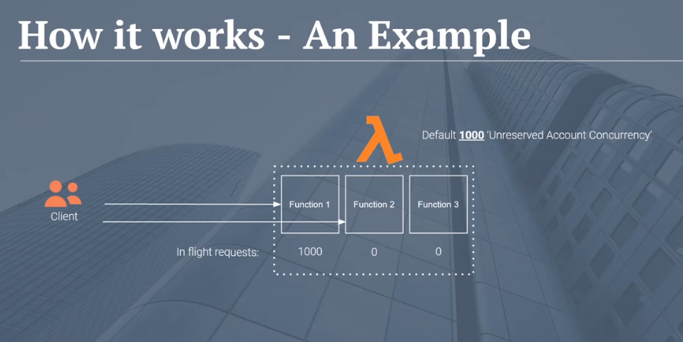  
  
when SNS calling lambda then if Due to Trottling stoping its request then lambda will return Trottling Exception but if you have configured retry policy on your SNS topic then again SNS will call lambda after period of time but after some times it will also stop….How to handle these exception - generally in logic in your code  
  
WHen asynchronous calling then Lambda will return instance or metadata about invocation in internal queue like Dead ladder queue and lambda will pull that queue internally to process that request now When it pulls the queue and it attemps to process that request , your concurrency limit is head if it will fail and it will put message back into the queue now again will retry ..LIke 3 times -- same method for SQL call  
